**Database Assignment**

**Task1**

| **Create Database hotelmanagement;**  **use hotelmanagement;**  **CREATE TABLE Customers (**  **cust_id int(11) NOT NULL,**  **cust_name varchar(255) ,**  **cust_city varchar(255),**  **cust_roomno int(11),**  **check_in_time DATETIME DEFAULT CURRENT_TIMESTAMP**  **);**  **INSERT INTO Customers (cust_id, cust_name, cust_city,cust_roomno) VALUES**  **(1, 'Adam', 'Los Angeles',101),**  **(2, 'Eve', 'Chicago',102),**  **(3, 'Axe', 'NY',103),**  **(4, 'Smith', 'Houston',104),**  **(5, 'Alen', 'Phoenix',105);**  **select * from Customers;** |
| --- |

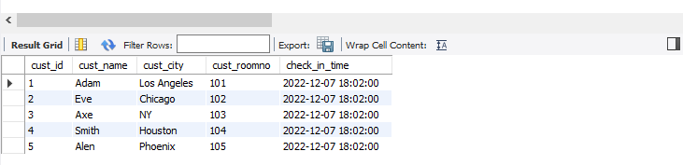

**Task 2**



**Finding count and list of distinct cities**

| **SELECT DISTINCT City FROM Customers;**  **SELECT COUNT(DISTINCT City) FROM Customers;** |
| --- |

**Finding min and max bought quantities**

| **SELECT MAX(Quantity) FROM order_details;**  **SELECT MIN(Quantity) FROM order_details;** |
| --- |

**Finding sum and Average in orderDetails**

| **select sum(Quantity) from order_details;**  **SELECT AVG(Quantity)FROM order_details;** |
| --- |



**Print the the products 5 to 15**

| **SELECT * FROM products LIMIT 4,11;** |
| --- |

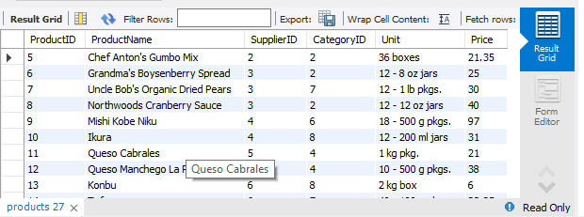

**Supplier Name with A in second position**

| **select * from suppliers where Suppliername like '_A%';** |
| --- |

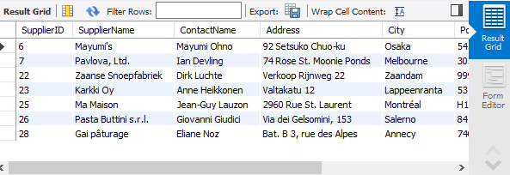

**Customers who are not in usa and canada**

| **select * from customers where city not in ('USA','CANADA');** |
| --- |

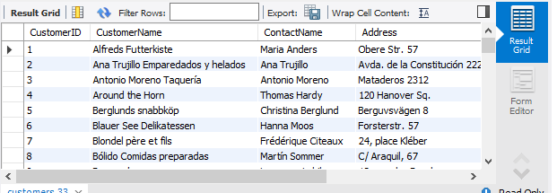

**Orders B/w 2020 and 2021**

| **SELECT OrderDate FROM orders;**  **SELECT * FROM orders WHERE OrderDate BETWEEN 2020-01-01 AND 2021-12-31** |
| --- |

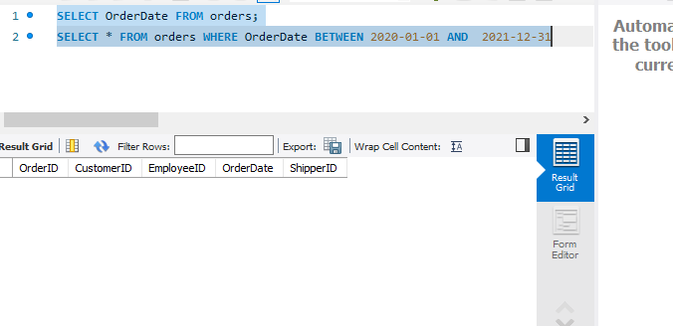

**Distinct cities**

| **Select distinct city from customers;** |
| --- |

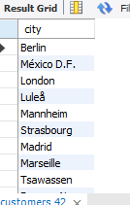

**Excluding the name sanjay and sonia**

| **select * from employees where LastName not In ('sanjay', 'Soniya');** |
| --- |

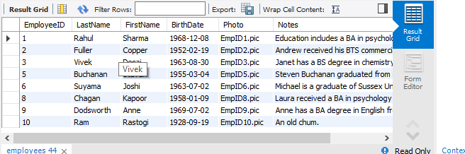

**Duplicate Table as Suplierdetails**

| **CREATE TABLE suplierdetails AS SELECT * FROM Suppliers;**  **select * from suplierdetails;** |
| --- |

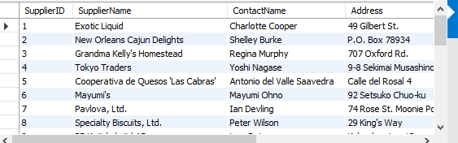

**Deleting the Country**

| **SET SQL_SAFE_UPDATES = 0;**  **delete from customers where Country='Venezuela';**  **Select * from customers;** |
| --- |

